# DSA LAB ASSIGNMENT 3 BT22CSH031

**1)**

#include <stdio.h> #include <stdlib.h>

struct Node {

int row, col, value; struct Node* next;

};

struct Node* createNode(int row, int col, int value) {

struct Node* newNode = (struct Node*)malloc(sizeof(struct Node)); if (newNode == NULL) {

printf("Memory allocation failed\n"); exit(1);

}

newNode->row = row; newNode->col = col; newNode->value = value; newNode->next = NULL; return newNode;

}

void displaySparseMatrix(struct Node* head) { if (head == NULL) {

printf("The sparse matrix is empty.\n"); return;

}

printf("Row\tColumn\tValue\n"); printf(" \n");

struct Node* current = head; while (current != NULL) {

printf("%d\t%d\t%d\n", current->row, current->col, current->value); current = current->next;

}

}

int main() { int m, n;

printf("Enter the number of rows and columns of the matrix: "); scanf("%d %d", &m, &n);

struct Node* head = NULL;

printf("Enter the elements of the matrix:\n"); for (int i = 0; i < m; i++) {

for (int j = 0; j < n; j++) { int element; scanf("%d", &element);

if (element != 0) {

if (head == NULL) {

head = createNode(i, j, element);

} else {

struct Node* newNode = createNode(i, j, element); newNode->next = head;

head = newNode;

}

}

}

}

printf("Linked List Representation of Sparse Matrix:\n"); displaySparseMatrix(head);

while (head != NULL) {

struct Node* temp = head; head = head->next; free(temp);

}

return 0;

}

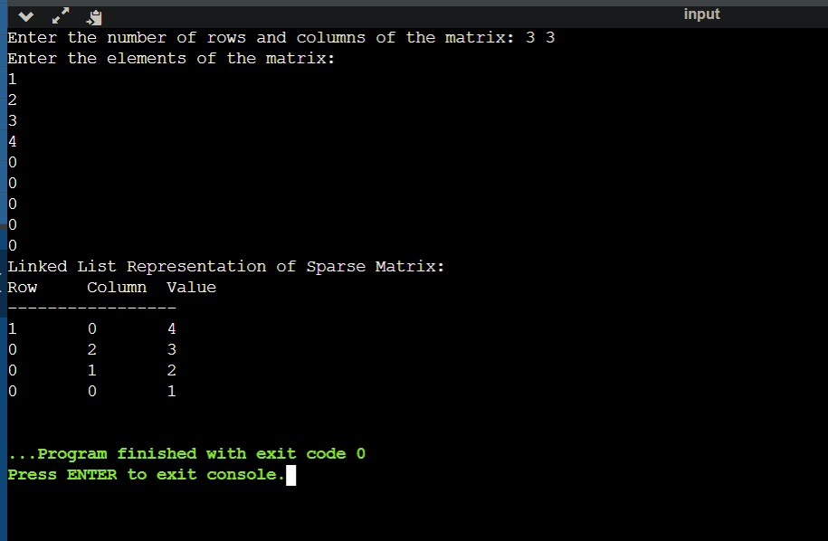

# 2)

#include <stdio.h> #include <stdlib.h>

typedef struct Node { int data;

struct Node* next;

}Node;

Node* newNode(int data)

{

Node* new_node = (Node *)malloc(sizeof(Node)); new_node->data = data;

new_node->next = NULL; return new_node;

}

void push(Node** head_ref, int new_data)

{

Node* new_node = newNode(new_data); new_node->next = (*head_ref);

(*head_ref) = new_node;

}

Node* addTwoLists(Node* first, Node* second)

{

// res is head node of the resultant list Node* res = NULL;

Node *temp, *prev = NULL; int carry = 0, sum;

while (first != NULL || second != NULL) {

sum = carry + (first ? first->data : 0) + (second ? second->data : 0); carry = (sum >= 10) ? 1 : 0;

sum = sum % 10;

temp = newNode(sum); if (res == NULL)

res = temp;

else

prev->next = temp;

prev = temp;

if (first)

first = first->next;

if (second)

second = second->next;

}

if (carry > 0)

temp->next = newNode(carry);

return res;

}

Node* reverse(Node* head)

{

if (head == NULL || head->next == NULL) return head;

// reverse the rest list and put the first element at the end

Node* rest = reverse(head->next); head->next->next = head;

head->next = NULL;

// fix the head pointer return rest;

}

void printList(Node* node)

{

while (node != NULL) {

printf("%d ",node->data); node = node->next;

}

printf("\n");

}

int main(void)

{

Node* res = NULL; Node* first = NULL; Node* second = NULL;

push(&first, 6);

push(&first, 4);

push(&first, 9);

push(&first, 5);

push(&first, 7); printf("First list is "); printList(first);

push(&second, 4);

push(&second, 8); printf("Second list is "); printList(second);

first = reverse(first); second = reverse(second);

res = addTwoLists(first, second);

res = reverse(res); printf("Resultant list is ");

printList(res); return 0;

}

